community-bonding ties ties between people within the same community.
community-bridging ties ties between people of different communities.
small-world network a network that is characterized by a high level of local clustering and low average path length.
The small-world network is located somewhere between order and randomness. If order ruled the social world, then personal networks would be completely transitive and there would be completely fragmented communities (only community-bonding ties) with no links between them (no community-bridging ties). It would be a “caveman world” (Watts, 2003) in which people could not “escape” their own community.
The opposite of such a completely ordered social world would be a world in which networks are formed entirely randomly. This would result in a small world too, but also in a world that is totally unrealistic: the chances that your friends know each other would be similar to any two random persons knowing each other. We have seen that, empirically, this is not the case. On the contrary, the chances that your friends know each other are very high (>75%), whereas such chances for two random strangers knowing each other are negligible.
You may wonder what type of ties connect different communities. Are these bridging ties different from community-bonding ties? According to Granovetter, there is indeed an important difference. He argued that because the transitivity tendency pertains in particular to strong ties, such strong ties tend to be more often communitybonding ties. Weak ties, however, tend to be less transitive, as we have seen, and hence tend to act as a bridge between different communities more often than do strong ties. In his own words: “No strong tie is a bridge. All bridges are weak ties” (Granovetter, 1973).
One theory that addresses these questions has a long history and originates from the 1887 study by the German sociologist Ferdinand Tönnies. He argued in this study that, over time, there is a shift from Gemeinschaft to Gesellschaft (Tönnies, 1957 [1887]). A Gemeinschaft is characterized by order: strong interpersonal bonds, solidarity and trust. In such a society, people are strongly embedded in communities, i.e., there are many community- bonding ties and such ties tend to be strong, enduring and supportive. In a Gesellschaft, however, social ties erode and become weaker, more loose and instrumental. According to Tönnies this change from Gemeinschaft to Gesellschaft, from social “order” to more “randomness” in social relations, has to do with population growth. In small-scale societies, people often meet each other face-to-face; they interact with the same people repeatedly, which strengthens social ties, creates trust and promotes reciprocity. As societies become larger, the opportunities for interacting with the same people shrink. People become more geographically mobile, which means that their friends and family members could relocate and settle in areas far away. Larger societies are also more urban, which likewise reduces opportunities for repeated interactions with the same individuals.
The loss-of-community proposition argues that the tie-strength in personal networks has reduced and that people tend to have more weaker rather than stronger ties. It also argues that personal networks are becoming less transitive because, as we have seen, transitivity is a positive function of tie strength.
Notice that, if you compare the theories of Tönnies and Putnam, the proposition they derive is the same (loss-of-community). But the causal mechanisms that set this process in motion are different according to the two scholars. While Tönnies emphasises the anonymity of living in large-scale populations in which people become strangers to each other, Putnam argues that it is modern technology that drives people away from establishing and maintaining strong ties.
However, scholars have not yet come to a consensus about whether the loss-of- community proposition is true: this is still a topic of ongoing investigation. Some studies confirm the proposition and others provide contradictory evidence (Fischer, 1982; Laumann, 1973; McPherson et al., 2006; Paik & Sanchagrin, 2013). There is, furthermore, an ongoing discussion about the presumed role of population size and urbanization in possibly reducing tie-strength (Fischer, 1982) and about the potential impact of modern communication technology (Wang & Wellman, 2010). In short: it is hard to distill stylized facts as this area of research is bound to too many uncertainties and any firm conclusions cannot be drawn.

The studies on the small-world networks and loss-of-community are part of a more general research interest in sociology, namely in describing and explaining the degree of cohesiveness of social relations—which I will also refer to as social cohesion. Such a cohesive society is then seen as the opposite of a fragmented, disintegrated society, in which there are many conflicts, negative ties, distrust and uncooperative behavior.
social cohesion the degree to which individuals and groups have (strongly) positive relationships with each other, as opposed to no/neutral relationships or (strongly) negative relationships.
The study of personal networks is part of the more overarching question about the degree of social cohesion in society.
The Tönnies–Putnam studies document whether positive ties change in strength—from strong to weak—or become absent, but they do not consider negative ties. These are ties that undermine the well-being, personal development and resources of individuals. The more common these kinds of negative ties are in personal networks, the lower the social cohesion in society. It is helpful to differentiate between three possible relationships between any two actors in a population
Positive relationship (+). In these kind of relations people tend to help each other, cooperate and trust each other—although the extent to which this is the case depends on tie-strength.
• Negative relationship (−). These kind of relations indicate that two persons have a conflict, or they dislike each other, or don’t trust the other person. Similar to positive ties, negative ties are also a matter of degree.
• No/neutral relationships. Relationships between two people need not be either positive or negative. Sometimes, people simply don’t know each other. Or they might not be friends, but neither are they foes or enemies to each other No lines drawn to denote this on sociogram
With this in mind, you can see that if you take a representative sample of individuals in society and study the positive and negative relationships in personal networks, you would be able to aggregate your findings to the societal level and draw conclusions about the cohesiveness of its social structure. You could say whether, generally speaking, people are positively connected to each other, that relations have eroded or that negative ties prevail.
Study Family sociology, Sociology for adolescence and youth, Organizational sociology
The more common positive ties are in personal networks, as opposed to negative ties, the higher the personal network cohesion. The cohesion of personal networks is therefore one important dimension of the social cohesion in society at large
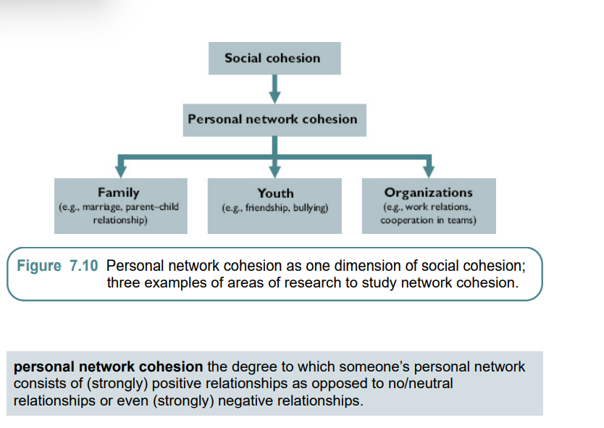
The core idea of the social capital paradigm is that social networks have some sort of “value,” that networks matter for certain desirable outcomes.
Social control theory argues that norm conformity is a function of expected social sanctions and approval.
This means that the density of network (1) is 1.0. Everyone is connected to everyone else. It is called a clique, such as often seen among adolescents’ closest friends in school.
Social norms, therefore, critically depend on monitoring. But what determines monitoring?
Coleman indicates such cohesive social webs with the concept of network closure, and he argues that in such a highly connected, dense and clustered network people strongly monitor each other’s behaviour. For example, if person A tends to free-ride and cheat, both B, C and D notice such behaviour and sanction A
We can formulate Coleman’s network closure and norms proposition as follows: P. The degree of closure in a certain network has a positive effect on the conformity to the social norms of that network. (network closure and norms)
This leads us to the tie strength and trust proposition: P. The more positive the relationship between ego and alter, the more they trust each other. (tie strength and trust)
Particularized trust is trust in the smaller circle of closely related people, which typically include friends, family members and others with whom one frequently interacts, and who are embedded in the communities of interrelated ties to which one belongs. Generalized trust is trust one places in people in general, beyond one’s friends and immediate social surroundings, such as strangers and political leaders

Health and well-being A third line of social capital theories focuses on health and wellbeing(the other being norms and trust)
In summary, research findings suggest that social networks impact people’s health and well-being. Those who have more cohesive personal networks and those whose social network ties are healthier and happier tend to have better health outcomes ehhhh Ngl
Summary pg 440
Groups can be sources of social and emotional support, financial assets, protection and well-being. What actually is a “group?” A common definition of a group is that of a social category to which people could be affiliated. Group or affiliation network
The collective benefits generated by groups when they organize themselves has attracted scholarly attention. A classic study is Putnam’s Making Democracy Work (Putnam, Leonardi, & Nanetti, 1993).
The reason for this north–south difference, Putnam posits, is that in the north there is more of a civil society, i.e., a society (region) consisting of a cohesive web of voluntary associations. In the north there are more sports clubs, music clubs and other voluntary associations than in the south and people in the north actively participate in these groups. According to Putnam, such a vibrant associational life promotes cooperation, solidarity, trust and norm enforcement, which are necessary elements for well-functioning, efficient democratic institutions.
French sociologist Tocqueville in Democracy in America. Tocqueville, while travelling through the United States in the 19th century, noticed that there were far more religious organizations, social clubs and other kinds of voluntary organizations over there than in his home country of France (De Tocqueville, 2002 [1889]). Such over-time and cross-country differences in voluntary association involvement has become an important topic of research in sociology Food for thought indeed
The degree of voluntary association involvement in society can be seen as another dimension of social cohesion: the stronger the degree of associational involvement in society, the stronger its social cohesion. This particular type of social cohesion will be indicated as organizational cohesion. This dimension of social cohesion is analytically different from personal network cohesion, which was introduced in Chapter 7, and it differs from intergroup cohesion
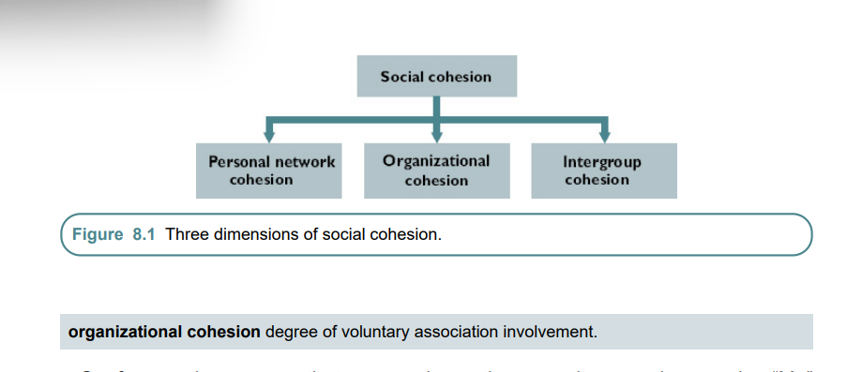
Therefore, associational organizational cohesion may undermine social cohesion in society if such organizations cause out-group members harm. KKK, RSS and so forth
Scholars therefore study intergroup cohesion as a third dimension of social cohesion, i.e., the degree to which (members of different) groups in society have positive relations with each other as opposed to negative relations. It is important to differentiate organizational cohesion from intergroup cohesion because these different dimensions of social cohesion do not necessarily overlap.
A society can have strong organizational cohesion and yet weak intergroup cohesion. Taliban society
intergroup cohesion degree to which (members of different) groups in society have positive relations with each other as opposed to negative relations.
The study of intergroup relations is spread over four areas of research, each looking at different aspects and different indicators of Us versus Them intergroup relations in society
• Group segregation. Scholars study friendships, marriage and cohabitation and other types of positive social ties between people of different groups.
• Intergroup attitudes. Scholars study intergroup attitudes, a more subjective indicator of social distance between groups. The Us–Them divide is stronger when people have strong positive views about their own group and think very negatively about the out-group.
• Intergroup trust, solidarity and cooperation. Scholars examine how much people trust in- and out-group members, how much cooperation and solidarity there is between Us and Them.
• Intergroup aggression and conflict. Finally, scholars study acts of aggression and conflict, and when such acts are more common between groups they are a clear signal that intergroup cohesion is undermined.
Group segregation
group-bonding tie tie between two individuals who belong to the same group.
group-bridging tie tie between two individuals who belong to a different group.
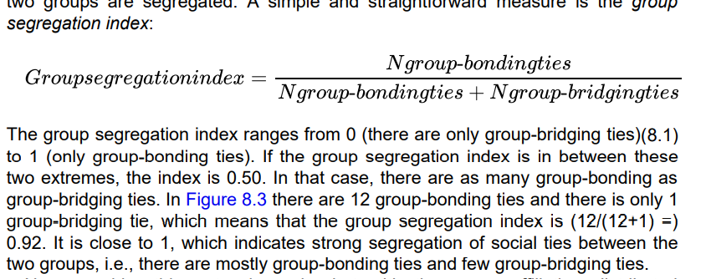
Researchers talk about endogamy when people marry someone from their own group. When people marry with a member of an out-group one speaks about exogamy, intermarriage or mixed marriage.
They teach us the same lesson, namely that the Us–Them divide in social ties is a common pattern, a universal stylized fact. People tend to befriend and marry in-group members more often than out-group members. This empirical pattern has been found with respect to racial groups, ethnic groups, religious groups, status groups, but also with respect to gender, age and education
This well-known empirical regularity is expressed in the popular sayings “birds of a feather flock together” and “like associate with like.” In the scientific literature it has also been called homogeneity bias, network homogeneity and network autocorrelation.

Why are friendship relations in society divided by group affiliations? Scholars have identified different mechanisms that underlie this phenomenon. I will review the two most important ones first: opportunities and homophily, loosely called “constraint-” and “choicebased” mechanisms. After that I will briefly discuss two more mechanisms: transitivity and third-party effects.
In essence, the theory argues that group segregation arises as a result of (unequal) meeting opportunities between members of different groups.
The second argument of opportunity theory connects the social context (macro and meso) to the micro level. It states that the “pool of people” we meet is dependent on “structural opportunities” (arrow b), i.e., the meeting opportunities created by the social context in which people participate. Thus, the opportunity theory argues that the contexts in which people participate generally constrain their possibilities to meet people from other groups (arrow b), that such reduced intergroup meeting chances result in the development of group-bonding ties at the individual level (arrow c) and that from this process
So, what determines the opportunities for meeting in- and out-group members? Blau introduces several structural constraints. One of these is group size, i.e., groups differ in how many members they have. The mere size of a group can be a key contextual condition that shapes meeting opportunities. Members of larger groups have ample opportunities to interact with in-group members, whereas people who belong to smaller groups have more restricted opportunities for meeting and interacting with in-group members. One consequence of this is that members of larger groups tend to marry more often with in-group members than do those of smaller groups Most interesting
foci social settings in which people participate and that create the pool of people we meet.
This means that people more often meet someone from their own race or socioeconomic class in school, at work and in their neighbourhood. Literature has found that, indeed, the segregated composition of foci tend to contribute to the emergence of group segregation in social ties Rich liberals could use this as an explanation for the lack of their black friends
The name homophily is composed of the Greek words “homo” (meaning “same”) and “philos” (“love”). As the meaning of this word already suggests, the homophily theory states that people prefer those who are the same as themselves. In other words, it argues that people selectively choose to interact with and befriend others who are socially similar to them at the expense of contacts and friendships with people who belong to out-groups. Contrary to the popular saying that “opposites attract,” the homophily proposition states that “like prefers like.”
Okay so structural opportunities(constraints//> group size & consolidation) and Homophily(choice)
Other mechanisms: transitivity and third-party effects
One has to do with transitivity, i.e., the fact that your connections tend to know each other as well. This tendency can reinforce group segregation
Another social force that further strengthens group segregation has to do with the role of third parties (Kalmijn, 1998). According to third party theory , relationships are not made in a social vacuum: there are other actors (hence the label “third” party) that interfere with the relationship between two persons. Third parties can be formal institutions, such as the state, but also informal parties such as peers, parents, other relatives and group members. The idea of third party theory is that these parties prescribe norms that approve, disapprove or even prohibit relationships between members of certain groups and that these third parties also monitor behaviour and sanction in case of norm-violations. The third party theory can be seen as an application of social control theory
. It is more generally found that people have a tendency to hold positive attitudes towards their own group than towards other groups. This tendency is sometimes called ethnocentrism
minimal group paradigm studies which reveal that arbitrarily created groups which have no interaction between members already reveal in-group favouritism.
Why do people trust in-group members more and allocate more resources to in-group members, even when they have no personal ties to them? One influential answer to these questions is provided by social identity theory, which was developed by Tajfel and Turner in the 1970s and 1980s
Social identity theory assumes that people strive to maintain or enhance their self-esteem, that, in other words, they strive for a positive self-concept. People’s self-concept depends not only on their personal identity (i.e., someone’s unique abilities) but also on their social identity. What matters less, according to social identity theory, is that individuals belong to a group in an objective sense (e.g., group membership or participating in some group activity), which may be assigned by “others,” and what matters more is that individuals subjectively identify with a certain group. People strive to maintain or enhance a positive social identity, which can be realized by making favourable comparisons between the in-group and the out-group. The aim of in- and out-group differentiation is to maintain or achieve superiority over an out-group on some dimensions. According to this theory, so Tajfel and Turner posit, “when social identity is unsatisfactory, individuals will strive either to leave their existing group and join some more positively distinct group and/or to make their existing group more positively distinct” (Tajfel & Turner, 1979).
In-group favouritism There is a general tendency that individuals have more positive in-group relationships than outgroup relationships, as observed in research on intra- and intergroup (1) social ties, (2) attitudes and (3) trust, cooperation and solidarity
The take-away message of these case study findings is that, beyond the baseline tendency of in-group favouritism, intergroup cohesion is contingent and varies across social contexts.
One influential sociological theory that explains the contingent nature of intergroup cohesion is called group threat theory. The Robbers Cave Experiment highlighted the key role of group competition for creating intergroup tensions. This finding is at the core of group threat theory.
I represent group threat theory in a multilevel framework. As you can see, the key outcome to be explained is the degree of intergroup cohesion. Group threat theory posits that actual group competition in a certain social context decreases intergroup cohesion (arrow a), i.e., intergroup cohesion will erode under conditions of group competition. It means that, if the level of competition between groups rises, there will be (1) an increase in group-bonding ties and a decrease in group-bridging ties, (2) intergroup attitudes will become more negative, (3) members of different groups will distrust each other more and refuse cooperation with outgroup members and (4) intergroup aggression and conflicts will become more likely. Note that this is an ecological relationship (Chapter 4), i.e., a relationship at the collective (group) level: the higher the actual competition between groups, the lower will be cohesion between groups.
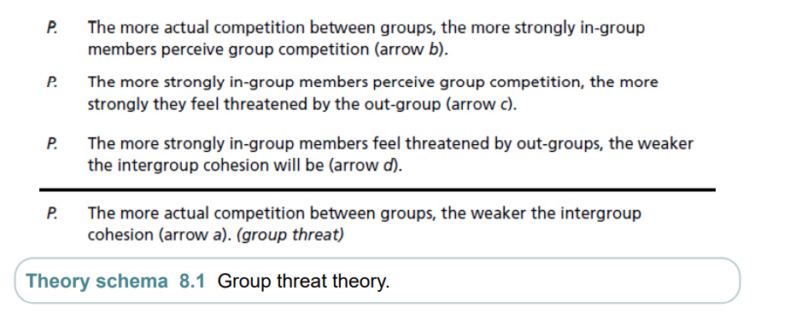
Economic competitive conditions
To begin, groups compete for scarce economic resources. The theory assumes that people have, first and foremost, basic physiological needs, i.e., they want food, water, warmth, shelter. This should weaken intergroup cohesion, according to the theory, because people perceive their in-group in competition with out-groups for the scarce jobs and houses. They feel threatened by out-groups, who they think will take away their jobs and houses
Essentially economic competition that plays into group threat theory. Jews???? Jewish minorities have suffered from social segregation, suppression, discrimination and collective violence and murder as a result of stereotypical beliefs about their group (Bauman, 2005 [1989]). But violence against Jewish minorities appears particularly common under conditions of economic scarcity, for which they are blamed.
Cultural competitive conditions
Groups can compete with each other for cultural (symbolic) reasons too. Culture, as we have seen, consists of a set of opinions, norms and corresponding practices. Importantly, groups can have distinctive cultures, such as having different languages, religions, values and norms. According to group threat theory, such cultural distinctiveness can become a source of “symbolic” threat. Group members may fear that the culture of the out-group will undermine their own culture;
The more the cultural distance between two groups in the population, the weaker the intergroup cohesion
In that case, the threat of the out-group is neither economic nor cultural, but rather one of physical safety: people become concerned that they, or their friends or relatives, will be the next victim of the violence of the out-group. These perceptions could result in a feedback effect as in Hindu–Muslim violence in India and the Protestant–Catholic conflict in Northern Ireland, to name only a few cases that followed this pattern.
Summary 486
between-country stratification unequal distribution of valuable goods between countries
within-country stratification unequal distribution of valuable goods within countries.
social class group of people who hold similar occupational positions.
A prominent example is the so-called Erikson-Goldthorpe-Portocarero (EGP) class scheme, which differentiates (in an often-used collapsed version) seven social classes: service class, routine non-manual, petty bourgeoisie, farmers, skilled workers, non-skilled workers and agricultural laborers
Thus, although unskilled workers earn less and have lower standards of living on average than, say, professionals, at the same time there are disparities in earnings and living standards within this group of unskilled workers. To overcome these problems, sociologists have developed the so-called socio-economic index of occupational status (Ganzeboom, De Graaf, & Treiman, 1992). The socio-economic index of occupational status ranks each occupation along a continuum rather than grouping them together in broader clusters of occupations in heterogeneous social class schemes. Specifically, the index is constructed as a function of the average education and income of individuals within each occupation. Thus, those occupations that are characterized by highly educated workers who earn a lot are seen as occupations with a high socioeconomic status.
social status subjective ranking of individuals or groups in terms of honor, esteem and respect.
occupational prestige subjective ranking of occupations in terms of prestige and respect.
Treiman constant Occupational prestige rankings are highly similar over time, across countries and have strong agreement between raters.
Social class and status are typically seen as core bases of social stratification, i.e., the unequal distribution of valuable goods.
One measure that scholars often use to assess the degree of overall income stratification in society is the Gini coefficient. The Gini is a summary measure of stratification, which runs from 0—in which case all citizens have the same income (or wealth, etc.)—to (almost) 100—in which case a country’s entire income (or wealth, etc.) is in the hands of one single person.
Just a measure of income stratification
The second sub-theme of inequality examined by sociologists is, therefore, social mobility in a society (Grusky, 2001). Whereas the study of stratification is concerned with the unequal distribution of valued goods, the study of mobility focuses on changes between social positions.
intergenerational mobility changing position between parents and their children in the stratification system.
intragenerational mobility changing position in the stratification system over the life course.
For example, among the parental generation (origins), there were 500 lower class positions. But among the next generation (destinations), there are only 400 such positions. This means that among the 500 children who come from a lower-class background, only 400 can occupy the same position as their parents: the remaining 100 are “pushed into” another class because of changing labor market structure. structural mobility mobility that is due to changes in the volumes (margins) of available social positions. relative mobility inequality between children from (different) social origins in their opportunity to access social positions. To get a better understanding of the true openness in society across generations, its social fluidity, sociologists argue that we need to examine relative mobility
Odds ration pg 522
The study by Blau and Duncan gave great impetus to the sociological investigation of the importance of “ascription” versus “achievement” in social mobility.
Ascription characteristics set at birth, such as family origin and ethnic origin.
Achievement personal effort, skills, talent and performance.
It is argued that modernization changes the status attainment process in the following two ways:
1. Ascription becomes less important. Modernization is argued to reduce the impact of someone’s family origin. Whether your parents are rich or poor, high or low educated, lawyer or truck driver, matters less today than in the past for your chances of getting a good job. This means that parents’ socio-economic status has less of an effect on (1) their children’s education (arrow a) and (2) their children’s occupational status (arrow b). In modern nations, social origin matters less for where you end up in your career.
2. Achievement becomes more important. Modernization also changes the role of education. Specifically, the theory posits that education is playing an increasing role in determining your chances in the labor market.
This so-called industrialization and mobility hypothesis has been studied in various countries and findings are mostly in line with it. I
- Increasing specialization. Modernization encompasses accumulation of technological knowledge and innovations. Higher levels of technology—such as a shift from agriculture to industrial society—goes hand in hand with increasing specialization. New jobs emerge, which require new skills and talents, meaning that children can no longer simply inherit the same job as their parents
- Educational expansion. Modernization also means educational expansion—more and more people attend primary and secondary education and increasingly people obtain university degrees.
- Increasing geographical mobility. Another societal change associated with modernization is that transport becomes more readily available due to improved infrastructure.

But as a general pattern, the conclusion we can draw is that ascription is becoming less and less important whereas achievement has become more important since the 19th century.
cultural reproduction theory emphasizes the (increasing) transmission of cultural capital from parents to children. a common and useful way to think about cultural capital is that it refers to resources that come from
(1) the affinity with higher status values, beliefs, norms and corresponding practices (e.g., high-status cultural activities like visiting museums) and
(2) language competencies. Thus, cultural capital encompasses, first, “good taste”: being familiar with the dominant values, ideas and behavior that are assumed to be typical of the school setting. For example, children who have visited museums with their parents, who have been taken to theaters and who have listened to classical music at home are more familiar with a school culture in which such high-status cultural values, norms and behaviors are dominant. But cultural capital also encompasses knowledge and, in particular linguistic competence. Being able to speak and write well in various languages is a key component of cultural capital. According to cultural reproduction theory, cultural capital can act as a compensatory mechanism, i.e., the strategic behavior of highstatus parents to maintain their high status in times of modernization.
^^Why the son of a professor is a professor. Look at the parents of Nobel laureates, Field Medallists
How strong is intergenerational mobility in income? In order to answer this question, scholars use a specific measure called intergenerational elasticity (IGE). Intergenerational elasticity measures the extent to which the relative position of parents in income distribution is a determinant for the relative position of their children in income distribution. The higher the IGE is, the lower the intergenerational mobility in income. If IGE is 0, the income of children is fully independent from that of their parents; if IGE is 1, the relative income position of the children is exactly equal to that of their parents.
The correlation between the two variables is 0.90, which means that countries that have higher levels of income stratification tend to have higher levels of intergenerational elasticity (and thus lower levels of intergenerational mobility). United States is a country with relatively high levels of social stratification and low intergenerational income mobility. In the US, children born in poor families less often climb the social ladder and get a high income than in Denmark and other Scandinavian countries. In other words, if you want to live the American Dream you should move to Denmark or Finland (Wilkinson & Pickett, 2009), where intergenerational mobility is much stronger than in the United States.
^Har har har
Summary page 543
Human capital people’s knowledge and skills insofar as these are relevant to the labor market.
Whereas human capital theory focuses on the role of your personal skills and resources, on “what you can do,” social capital theories instead consider the influence of social contexts, on “who you know.” In Chapter 7 (Networks) we have reviewed various social capital theories that argue that social networks can have important consequences for various outcomes: social norms, trust, health and well-being. Scholars have also proposed social capital theories which relate social networks to labour market outcomes
social capital theories on labour market outcomes
The various replication studies that have been conducted since Granovetter’s study, and which relied on larger and more representative samples, have revealed that informal methods are indeed important in finding a job. He concludes that around 30–50% of the jobs in these and other highly developed nations were found via informal channels
Therefore, the weaker ties—acquaintances and other persons with whom people rarely have contact—were somehow more “useful” to jobseekers than their strong ties—best friends and family. Weaker ties create bridges to other communities
Burt’s theory: structural holes
structural hole social network characteristic which refers to the lack of social ties between communities. brokerage network position which connects (otherwise disconnected) communities.

P. People who have a brokerage position in the social network of an organization have more favorable job outcomes. (brokerage and job outcomes
Lin’s theory: social resources
Lin considered the role of social resources, which in this context refers to valuable labormarket-related resources that are embedded in personal networks. These are all kinds of resources relevant for getting ahead in the labor market. Granovetter, as we have seen, argued that the job information of your connections is a very important resource (Granovetter, 1974). Lin and others have argued that social connections may also possess other resources relevant to the labor market.
For example, friends may help with writing a good application letter and they may know how to present in a job interview
Lin’s social resources and job outcomes proposition as follows: social resources valuable labor-market-related resources that are embedded in personal networks.
P. The more people’s social resources, the better their labor market position. (social resources and job outcomes)
position generator measure of social resources which captures the occupational positions of respondents’ connections.
Fascinating, the blue collars are not as high as I thought. Higher for the lay workers I see Pg 563 table
We have seen so far that scholars explain inequalities in the labor market with two types of resources, namely human capital (“what you can do”) and social capital (“who you know”). The third type of resource considers group affiliation (“who you belong to”). People belong to groups, i.e., social categories like ethnic groups, religion, gender and age.
Another perspective on discrimination comes from statistical discrimination theory (Phelps, 1972). This theory argues that discrimination arises from poor information that employers have when it comes to the candidates’ knowledge and skills. If employers had access to all the information about the productivity of all the candidates, discrimination would not occur.
Not too convincing in face of ingroup favouritism and conformity biases ngl
Employers, who cannot be sure about the candidates’ true productivity, use information about the (perceived) average productivity of the relevant groups (meso level) in order to better gauge the productivity of the individual candidate (micro level). Perceptions of group-level productivity are based on the human capital composition of the group, such as average education, language proficiency and health
P. The more strongly the groups to which people belong are discriminated against in the labor market, the worse their labor market position. (discrimination and job outcomes)
inequality of outcomes the relationship between social background and labour market outcomes
that children born in higher status families (social background) do better in the labour market (Blau & Duncan, 1967). Similarly, people born in deprived neighbourhoods (social background) are less likely to find a good job (Wilson, 1987). Children from broken families (social background) do less well in the labour market
The second process is called inequality of returns (arrow c), i.e., if you have more resources, you get more in return in the labor market. We have seen that having more human capital, more social resources, but also belonging to certain groups positively influences the chances of individuals in getting (good) jobs.
In summary, inequality of outcomes (i.e., between social background characteristics such as family structure) can be understood as resulting from the combination of inequality of opportunity (i.e., access to resources) and inequality of returns (i.e., the influence of resources on labor market outcomes).
correspondence testing field experimental method which uses resumes to detect discrimination.
audit testing field experimental method which uses actors to detect discrimination.
To understand this (persisting) gender inequality, scholars have argued that we need to consider the role of social norms and (internalized) aspirations, and how they (differentially) shape the careers of men and women.
So not just human/social capital
This explanation—which emphasizes the role of norms and aspirations—is called preference theory (Hakim, 2000) and gender ideology theory (West & Zimmerman, 1987). It can be seen as an application of social control theory. Social control theory can be used to understand gender inequalities in the labor market. By doing so, it posits that the social environment can affect the career ambitions that men and women may harbor, the value they attach to income and status and their preferences for certain jobs. Social norms can prescribe different roles and ambitions for men and women. Like sanctioned or Second, social norms can be internalized, which means that social norms become part of people’s individual preferences, goals and values. Men and women comply with these norms even in the absence of social control because deviations from their moral norms results in feelings of guilt and shame, or such internalized norms have become part of people’s personal values and preferences.
Sociologists Maria Charles and David Grusky state that there is actually a third way in which ambitions and norms generate gender inequality, Men and women work in very different occupations. For example, a primary school teacher, secretary and nurse are typical female jobs, whereas construction worker, car mechanic and electrician are male-dominated occupations. Broadly speaking, women crowd into the non-manual/non-technical section and men crowd into the manual/technical sector (Charles & Grusky, 2004). According to Charles and Grusky, this kind of occupational segregation by gender is universal; it has been observed across all countries in the world
Gender hypersegregation Men and women work in very different occupations in contemporary societies.
Although gender hypersegregation is universal, the degree of this occupational sex segregation varies across countries. In some countries occupations are more segregated by gender than in other countries. Sweden, for example, is well-known for its progressive gender values and norms, exemplified by family-friendly policies and high levels of female educational attainment and labor force participation. But occupational sex segregation is very strong in Sweden, even more so than in more gender conservative countries
Ahahha fucking hell counterintuitive
These findings are counterintuitive, but they reflect a broader pattern: in more economically developed countries, like Sweden, occupational sex segregation is more pronounced than in poorer nations like Botswana. The route towards gender segregation in the labor market can already start with the choices that boys and girls make in education. How can we explain these puzzling findings? Why do more economically developed countries have higher gender gaps in STEM fields and higher levels of occupational sex segregation? One explanation for this pattern emphasizes the role of cultural opinions
gender essentialist belief belief that there are traits that are distinctively male and female.
This gender gap becomes more pronounced in more economically developed countries because, in these countries, individual fulfilment and self-expression become increasingly important cultural values (Inglehart & Welzel, 2005). Higher levels of economic development reduce the prevalence of survival and collectivistic values and give rise to values emphasizing personal development, freedom and selfrealization (Welzel, 2013). Given the universal pattern of gender essentialist beliefs, however, the boys and girls in these economically developed, culturally individualistic countries think that these (male and female) traits belong to their core personality traits and that, therefore, they will find fulfilment in acting according to these (gender) traits (Charles et al., 2014). In the poorer countries, which tend to have more collectivistic values, gender segregation in occupations is less strong because both men and women work to survive and make a decent income. But in more individualistic cultures, women (and men) want to acquire jobs in which they can personally develop themselves and this means they will emphasize typically female (and male) traits such as nurturance, personal service and interpersonal interaction (or working with things, physical labor and technical skills). In other words, “men and women are motivated by a desire to express their authentic (gendered) selves” *********^^
Summary pg 596
It is conventional among social scientists to use the label second generation to indicate persons who were born in the host country but who have at least one foreign-born parent. By asking people about the parents’ birthplace, scholars are able to identify this second generation. The foreign-born population is then called the first generation.
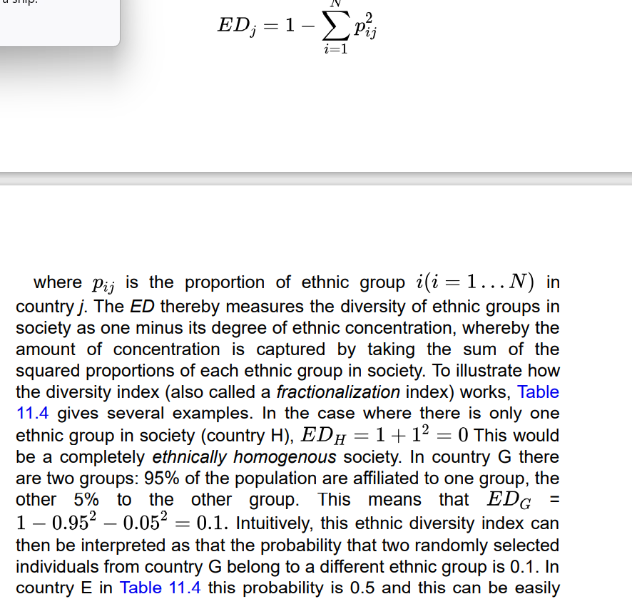
ethnic diversity ethnic heterogeneity of a population.
Immigrant Integration can be conceptualized as a normative issue (social problem) or as a social phenomenon (scientific problem). Obviously sociology treats it as social phenomenon
Three dimensions are typically distinguished and they relate to the CSI themes outlined in this book: culture, social relations and inequality (Drouhot & Nee, 2019).
• Cultural integration relates to the theme of culture. It indicates the degree of similarity between members of ethnic minority and majority groups with respect to cultural opinions, norms and corresponding practices.
• Social integration refers to the theme of social relations. It indicates the degree of intergroup cohesion between members of different ethnic groups. The cohesion between ethnic groups is stronger when (1) interethnic ties are more common, (2) interethnic attitudes are more positive, (3) intergroup cooperation, trust and solidarity is stronger and (4), intergroup aggression and violence is reduced.
• Economic integration relates to the theme of inequality. It indicates the degree of similarity between ethnic minority and majority members in realizing valued goals. If we say that an ethnic group is not fully integrated economically, it means that there are unequal chances between ethnic groups in realizing their goals.
In summary, a common sociological approach to the topic of integration is to consider it as a multi-sided, multidimensional social phenomenon.
P. With increasing length of stay of an ethnic minority group in a certain country, this ethnic minority group becomes more integrated. (immigrant integration)
In the literature, ideas very similar to this proposition are called the “assimilation model,” “straight-line assimilation,” “immigrant incorporation” and “adaptation”
However, some scholars have made a distinction between the concepts of “integration” and “assimilation” (Berry, 1997). I use the term immigrant assimilation to indicate a “stronger” version of the immigrant integration proposition, namely the proposition that, over time, the ethnic minority and majority groups become indistinguishable, fully “assimilated,” and eventually ethnic group affiliation is no longer a meaningful social categorization.
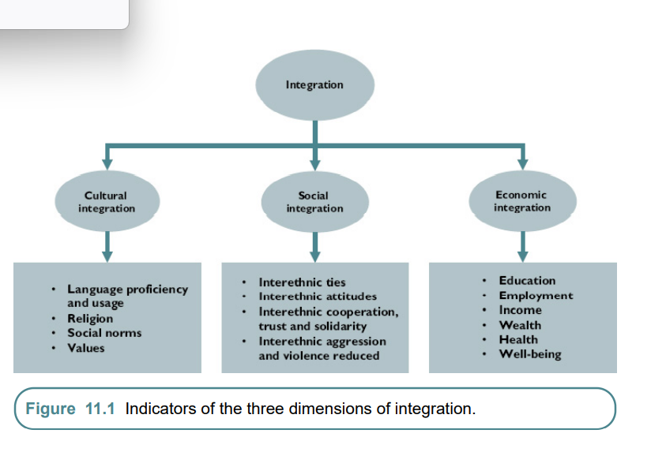
A common pattern found among ethnic minority groups is the three-generation language shift
Ethnic differences contribute to integration. Shown by empirical evidence of language shift theory? E.g Mexicans have lower L2 proficiency than other ethnic groups
Group size is an important contextual condition that helps to explain why Mexicans in the US speak L2 less well than do other groups. In the US they are a very large group, in particular when taking into account the fact that their mother tongue (Spanish) is also common among many other ethnic minority groups
Research on discrimination provides yet another example of integration spillover effects. In-group favoritism and anti-ethnic minority sentiments contribute to ethnic inequalities, which means that better intergroup cohesion (social integration) has a positive impact on economic integration. In conclusion, research findings indicate that the three dimensions of integration do not work independently. Although they are analytically distinct, in reality the process of economic integration depends on the process of social and cultural integration. When immigrants and their offspring acquire the official language, when group-bridging ties become more common, when intergroup sentiments becomes more positive and discrimination reduces, the chances of getting access to (better) jobs increases as well. Such spillover effects also emerge with respect to social and cultural dimensions of integration
Come back later after exam One of these theories is the famous Schelling model, named after economist Thomas Schelling. His ideas about this model were first published in the second issue of the Journal of Mathematical Sociology in 1971 (Schelling, 1971) and subsequently in his seminal book Micromotives and Macrobehavior, which appeared in 1978 (Schelling, 2006 [1978]).^^^^**** Agent based modelling?????
Shit good stuff, Schelling’s model of black hyper segregation. But is this toleration of at least 1/3 same race arbitrary?? Must read the original paper
The counterintuitive result of this simple Schelling model is therefore that extreme levels of segregation can emerge under conditions of mild in-group preferences. This collective outcome, moreover, is a stable situation, because everyone lives in a neighborhood that is satisfactory to themselves and there is no reason to move. Once a hypersegregated society is created, in other words, it is hard to change.
Summary pg 657
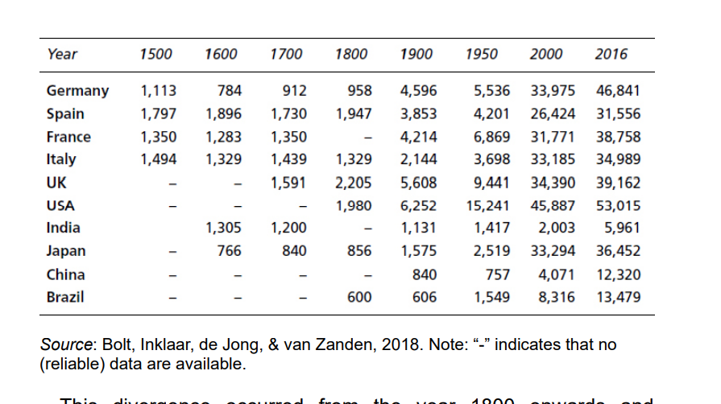
Fascinating
The trends in wealth and health and in peace and safety go in the same direction. Let’s take these two long-term developments together, which I will refer to as socio-economic progress. How can we explain this long-term trend? Why is there socio-economic progress? Why do we see improvement in wealth and health? Why has violence declined in history and has the world become a safer place?
In particular, the emergence of legal norms and the enforcement of these norms by formal authorities (Hobbes’ Leviathan) in well-functioning institutions may be an important driver for socio-economic progress (Acemoglu & Robinson, 2012).

There can be rationality at the individual and collective level. An individual can be very smart and skilled or not so and so, too, can we think of the rationality of collective cultures—the aggregate of people and their knowledge. Cultures are “collective brains” (Henrich, 2015), which can be more or less “rational.” Highly rational cultures have deep understanding of how the world works; a high level of knowledge; a highly diverse, specialized and complimentary set of tools and skills. Highly rational collective brains are better able to realize fundamental human goals—wealth, health, peace, safety— more successfully than in cultures that are based on limited understanding of the world, in which perceptions and beliefs are based on authority and superstition instead of logic and empirics. Collective rationality does not come out of the blue, as something one generation invents. Instead, collective rationality is the result of cumulative processes, in which one generation passes on knowledge to the next generation. Sometimes, knowledge gets lost but, according to Max Weber, one could distil a long-term process in which cultures become increasingly rational
That is to say, the collective opinions are becoming more and more accurate; they are increasingly based on empirical evidence and on logical thinking. Knowledge is becoming more scientifically grounded and rational. Increasingly, people adopt a scientific worldview, i.e., their perceptions and ideas are more and more shaped by scientifically informed empirical knowledge and logical thinking, on ideas that are more accurate and which can better explain how things work. Less and less so, Weber argued, cultural opinions are based on false perceptions, on ideas that are not true, on premises that do not match reality. But also, opinions that are not empirically testable (largely or entirely so) have lost their popularity. Hence, mythical thinking, superstition, religion and magic and other nonscientific beliefs have become more marginal over time. According to Weber “The fate of our times is characterized by rationalization and intellectualization” (Weber, 1919).
Weber’s rationalization thesis < Technological progress/ Scientization
Flynn effect gradual increase in skills and abilities of populations in developed countries between 1930 and 1995. Well quite controversial in the IQ circles ngl
the gradual increase in skills and abilities of populations in developed countries between 1930 and 1995—as evident from increasing IQ scores in that period (Flynn, 2007). Note that after this period there is no clear evidence for further IQ improvement So there is a cap?
Scientization Over time, human cultures have become more science-oriented. There is a growth of scientific knowledge; more formal education; increasing literacy, knowledge and skills.
McDonaldization
We have seen that human cultures have witnessed a process of rationalization in terms of technology, science and education. In line with Weber’s rationalization hypothesis, we have found that cultures have become more technologically advanced, more science oriented, that literacy has increased and that more and more people receive formal education. According to Weber, however, the rationalization process is not restricted to the domains of technology, science and education. To him, rationalization is a process that affects all segments of society. What we see, according to Weber, is that the economy, politics, sports, arts and other domains in society are becoming increasingly rationally organized as well. That is to say: the rationalization process—increasing scientific thinking, efficiency, prediction and control—is not limited to technological and scientific knowledge and their corresponding products and practices, but spreads out to many different domains. What McDonaldization means
Inherent features of the scientific method are increasingly applied to areas outside academia, i.e., the growth of quantification, standardization, transparency and evaluation, testing and evidence-based products and practices. Taken together, this techno-scientific rationalized culture will be diffused to other sectors of society: to economic production, politics, organizations, sports, arts, health care and so forth.
In his work, Weber described how organizations have become more rational over time and how the elements of a rational culture gradually pervade modern, bureaucratic, organizations.
Bureaucratization means, first of all, that processes become more efficiently organized, which results from division of labor and formalization of rules and procedures. Specialization is a core element of increasingly rationalized societies, i.e., more and more workers are experts in highly specific fields, well-defined tasks or certain skills.
Elaborating on Weber’s ideas, the sociologist Ritzer coined the term McDonaldization (Ritzer, 2011). The process of McDonaldization refers to the broader rationalization tendencies of societies, as found in organizations, sports, arts and so forth. McDonalds is a paradigmatic case of an organization that is characterized by high efficiency, predictability and control, which adopted the scientific method and hence the scientific management principles by standardizing, quantifying and evaluating almost everything.
Rationalization and socio-economic progress are actually seen as two dimensions of the concept of modernization
What are the consequences of modernization? What does the process of modernization mean for cultures (opinions, norms), social relations (networks and groups) and inequality (stratification, mobility and resources)? Putnam, as we have seen (Chapter 7), speculated that technological changes will bring about changes in personal networks, that modernization leads to a loss of community (Putnam, 2000). Blau and Duncan (Chapter 9) argued that modernization will change social mobility, such that achievement becomes more important and ascription less so (Blau & Duncan, 1967). Let’s take a look at whether modernization has also influenced two other social phenomena, namely (1) value change and (2) population structures.
Does modernization result in a change of human values? There exists a long tradition in sociology in which scholars have claimed that modernization results in a shift from “collectivistic” to “individualistic” valuesAll three authors make the distinction between individualistic values (in short: individualism) and collectivistic values (collectivism)
individualism (also emancipative values) individualistic values, such as emphasis on autonomy and personal choice.
collectivism collectivistic values, such as emphasis on group loyalty and authority.
Individualistic and collectivistic values manifest themselves in specific values regarding family, school, politics and gender
Individualization In the period between 1800 and 2015 there was an increase in individualistic values at the expense of collectivistic values in societies.
Empirical research has found strong evidence for the modernization and individualization proposition. When societies become more technologically advanced, more science oriented, higher educated and more prosperous and safer, then cultural values shift from collectivistic to individualistic.
Does individualism mean more egoism and selfishness? Welzel, in his book Freedom Rising (Welzel, 2013), has argued and indeed found that individualistic, emancipative values are actually associated with “pro-civic” orientations. Following Tocqueville (De Tocqueville, 2002 [1889]), Welzel defines civicness as “a benign mentality characterized by a concern for the well-being of the outer world beyond one’s ego and in-group”. Civicness in this sense includes:
• an unselfish orientation toward others and the environment,
• a trustful orientation that bridges group boundaries,
• a humanistic orientation that welcomes people’s diversity.
Welzel finds evidence to suggest that emancipative values promote pro-civic orientations. In turn, so Welzel argues, the rise of these emancipative values and pro-civic orientations has subsequently contributed to the emergence of legal norms (laws) that protect people’s citizen rights (Welzel, 2013). Thus, an increasing demand to guarantee human rights has stimulated the emergence of formal norms that protect these civil rights. Such rights have not been protected in autocracies, in which people were treated unequally and in which violence towards and torture of citizens was not uncommon. Welzel argues that the rise of emancipative, pro-social values explains why autocratic governments have become less common over time and gradually replaced by democracies.
How can we explain the ecological relationship between modernization and individualism? How can we make this macro-level relationship “understandable” (Chapter 4)? One answer to this question is provided by the so-called existential insecurity theory
To understand the link between modernization and value change, we need to look at each relationship, one by one:
a. Ecological relationship. At the macro level, it is shown that modernization generally results in the rise of individualistic values in society (arrow a). This is the modernization and individualism relationship.
b. Social context effect. Now, in order to understand this social change at the macro level (a), the theory postulates a social context effect: modernization generally results in a reduction of existential insecurities (arrow b). Technological progress results in more control over nature and in more material and economic resources. Poverty levels are reduced, people are healthier, all sorts of existential insecurities and threats diminish. In modern societies people do not have to struggle for survival as much as they did in the past.
c. Shifting value priorities. These reduced existential insecurities result, in turn, in changing priorities of values (arrow c). This is a micro-level relationship. When people face continuous existential threats, much depends on loyalty to their group. That’s why Inglehart also called these “survival” values, very much borrowing his ideas from Maslow’s hierarchy of needs, which emphasized that people first want to secure their physiological and safety needs and group belonging before they come to emphasize esteem and self-actualization. With growing control over nature, more personal resources and increasing securities, such collectivistic “survival” values become less useful. Instead, the utility of individualistic “emancipative” values increases, at the expense of the utility of collectivistic values (Welzel, 2013). People become less dependent on their group for survival and that opens up opportunities to prioritize new values, such as self-expression, making autonomous choices, equality of opportunities and other individualistic values. People adapt their values to the changing conditions.
d. Aggregation. Finally, as individuals are changing their value priorities in society so, together, as a population, the collective, aggregated values in society are changing.
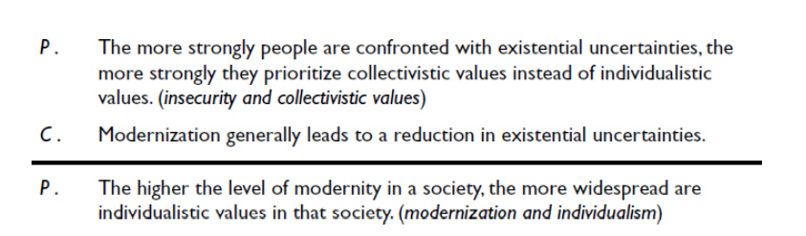
Two long-term patterns in human population structure can be distilled, namely: (1) a decrease in mortality and (2) a decrease in fertility. Demographers often take these two population-level changes together and call them the demographic transition, i.e., the transition within a population from high fertility and high mortality to low fertility and low mortality. In some societies, the demographic transition has just begun, whereas in other societies this happened already a long time ago.
second demographic transition change within a population towards extremely low fertility levels.
The steep decline in marital fertility after the early 1960s in the West is … also a recent indicator of the autonomous progression of an individualistically oriented Western value system: it coincides with the legitimation of cohabitation outside marriage, voluntary childlessness, nonconformist sexual behavior, abortion, and euthanasia. (Lesthaeghe, 1983)
is part of a more general change in family preferences and behavior. European countries have become more affluent over time, particularly after WWII, which decreased the support for collectivistic values—emphasizing conformity to family and survival strategies— and gave rise to individualistic values—focusing on the needs of the individual. Hence, collectivistic family values that emphasize the importance of marriage and having large families have become less popular, whereas individualistic family values—cohabitation instead of marriage, having children for pleasure instead of necessity—have become more common.
What can we conclude from this chapter? The history of human societies reveals a pattern called modernization. There is increasing technological knowledge, growth of science and education— rationalization—and improved health, wealth, more peace and safety —socio-economic progress. Modernization results in changing values—from collectivistic “survival” values to individualistic “emancipative” values and to changing population structures. These broad historical trends raise certain questions: (1) why are human beings actually so pessimistic about societal changes? (2) how can we explain the rationalization trend? and (3) why do we see exponential increase?
optimism gap situation in which people are more positive about their personal lives than they are about society
availability heuristic cognitive bias that people’s judgment of the probability of events, or the frequency of a kind of thing, depends on the ease with which people can think of certain information.
^^Why we are pessimistic about future
So, there is an evolutionary mechanism, a social learning bias, towards the successful transmission of more accurate and more rational beliefs and more efficient and convenient products and practices. Via the well-known S-shaped diffusion process, eventually the entire population (or most of them) adopts these more accurate beliefs, products and practices. Occam’s Razor. Even if it goes against confirmation bias humans eventually adopt. Also evolutionary value to rational, correct, efficient beliefs and norms in face of detrimental or otherwise superstition, magical thinking
Why exponential growth?
Self-reinforcing process According to Lenski and Nolan, growth of knowledge is exponential because it is a self- reinforcing process (Lenski & Nolan, 2006). They argue that a major part of innovations are what they call inventions, i.e., combinations based on already existing elements of knowledge. The potential for such inventions is therefore a function of the number of elements . Also Improved cultural transmission. Some scholars have claimed that exponential cumulative culture can happen because of changes in the way information is transmitted between individuals. Renaissance?? What happened in the course of history is a change from one-to-one transmission, via one-to-many transmission, to many-to-many transmission This is the typical vertical diffusion of knowledge from parents to their children, from one generation to the next generation. In small-scale hunting-gathering communities most of the information was transmitted in this vertical way, from the parental generation to the children. horizontal diffusion of knowledge that allows for one-to-many transmission. Using mass media (books, newspapers, TV, radio), for example, information can be transmitted to many people at once.
Summary pg 742 Shortest summary for the largest chapter
In summary, you could study religion as a group phenomenon, hence relating the topic of religion to the sociological theme of social relations
Religions can also be studied as a cultural phenomenon
In summary, religions can be seen as cultural phenomena, as a more or less coherent set of cognitive beliefs, values, norms and corresponding practices
When studying religion, the social dimension (religious belonging) and the cultural dimension (religious believing) need not always go hand in hand. For example, a person could adhere to religious beliefs but not participate in religious activities (Davie, 1990). Or someone could actively attend religious meetings but not be a religious believer.
According to some scholars, religious groups may have been critically important for establishing large-scale cooperation when human populations transitioned from small groups into largescale anonymous societies (Norenzayan, 2015). This transition— from small-scale hunter–gathering populations to agrarian societies — is puzzling, because at that time there were no efficient governments established that could sanction people if they harmed other people or in any other way acted as a “free-rider.”
Durkheim argued that religious groups—and groups in general—have the capacity to unite people. He argued that when people belong to the same religious group, they trust each other more and are more willing to cooperate with each other. Importantly, religious identities can be broader than family/kin/clan identities. Hence, sharing religious identities makes possible solidarity, trust and cooperation with in-group members beyond the small hunting-gathering community.
collective effervescence shared religious activities. To prevent fakers
credibility-enhancing displays behaviors which signal that people are genuine believers. Ramadan, Salah, etc etc
Religious stickiness Religiosity tends to be rather stable over time and geographical areas.
Thus, individuals born in highly religious societies tend to become highly religious persons themselves, because the previous (parental) generation transmits their high religiosity both directly (parent–child, “vertical” transmission) and indirectly (peer–peer, “horizontal” transmission).

Consider the trend for Belgium. Yearly changes in religious attendance are subject to fluctuations in survey estimates, but the long-term trend can be interpreted with more confidence. The direction of the trend is clear, namely that of declining participation. In the 1970s around 40– 50% attended religious meetings once a week or more. This diminished to 30–40% in the 1980s, and to 20–30% in the 1990s. Thus, in a period of roughly 25 years, weekly religious attendance dropped from around 45% to 25%. This general trend of declining religious attendance is not unique to Belgium. It is a pattern more commonly observed in Western-European societies.
Intragenerational Fascinating!!!!
How should we interpret this religious change? There are three potential factors. First, such change can be due to period effects, which means that periodic changing events bring about religious change. An example of a period effect would be that when the unemployment rate increases in a certain year, people become more religious.
Second, there can be age effects, which means that religious changes are associated with aging. An example of an age effect would be that, as people become older, they become more religious.
Third, there can be cohort effects, which refer to generational changes. For example, it could be that more recent cohorts—people born more recently—are less religious than people born a longer time ago.
secularization diminishing religiosity, i.e., decline in religious belonging and believing.
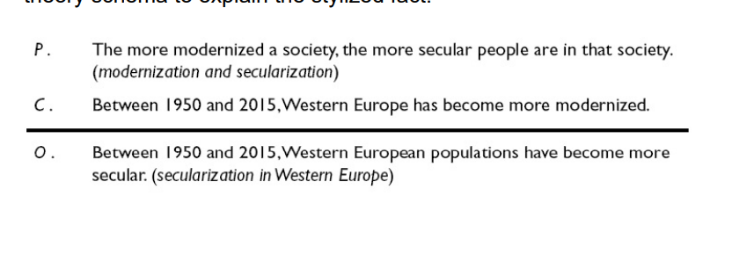
Very macro level ecological explanation.. a shame
In summary, we address the following theoretical question: Q(t). Why is it the case that, generally speaking, modernization results in secularization, and under which conditions does modernization not have this effect?

The starting point of the theory is that people are confronted with existential insecurities in their environment, both personally as well as for their friends and relatives. Humans are confronted with illnesses, death, poverty, violence and loss of beloved ones. According to existential insecurity theory, people turn to religion as a way to cope with these difficulties. This happens in two ways. 1. Group support. First of all, religions can provide support as a group. As we have seen, belonging to a group generates membership benefits. It fulfills the human need to belong to a group (Baumeister, 1991) and the emotional pleasure from collective effervescence—participating in group activities—as we have learned from Durkheim. Engaging in rituals (such as religious meetings) and other types of repetitive and predictive behavior (such as praying) gives a sense of control. Moreover, people can count on social support from in-group members, including cooperation, trust and protection from in-group members. This can be emotional support, but also financial assets, physical protection and other kinds of social security. In short, religious groups provide group support, as they protect members from poverty, violence and suffering.
2. Supernatural support. But religions also provide a set of cultural beliefs and values. Key to many religions is that they posit the existence of supernatural powers, which control the world and the after world. This gives meaning: even when things seem extremely difficult to accept—such as the loss of a relative— people can find comfort and meaning in the idea of an order created by supernatural beings and the existence of an afterlife or reincarnation. Religious meanings can make sense out of the pain and suffering of the individual or those who are close to them. In many religions, group members also have the ability to “negotiate” actively with these supernatural beings: they can “invest” in them and turn to them for a favor, for example by praying to them, giving them sacrifices and performing other kinds of rituals that serve them (Stark & Bainbridge, 1987; Stark & Finke, 2000). In return for that, people believe they will attain certain goals (with the help of God)—such as that their sick child will be cured or that they will have something to eat tomorrow.
stipulates that modernization (independent variable) impacts the religiosity of the country (dependent variable). Both are variables at the macro level, i.e., “modernization” is a property of a country and so is “the religiosity of a country.” You have seen that there is empirical support for this ecological relationship. Both technological development and economic development (as two key indicators of modernity) negatively relate to religiosity in the population.
Existential insecurity theory argues that in general modernity lowers existential insecurities (arrow d). People in primitive, poor nations face strong existential threats, such as high poverty rates and life-threatening violence. They are deprived of adequate medical facilities and, consequently, mortality rates are high, and deceases cannot be controlled very well. The insecurity and religiosity proposition then posits a micro-level relation between people’s experience of existential insecurity and their religiosity. This lowers the personal need for religion. Therefore, in the end, modern societies become less religious, although the aggregation process happens slowly and is delayed because changes happen through cohort replacement and not so much because of instantaneous events. Thus, existential insecurity theory argues that modernization impacts religiosity of societies in the long run.
In conclusion, what can we say about existential insecurity and religion? We have reviewed the evidence and it appears that predictions derived from the theory are largely supported in the literature. The theory explains the modernizationsecularization link, for the long-term secularization consequences of growing up in social welfare systems and hypotheses derived on short-term effects of extreme existential threats are largely confirmed as well (Figure 13.7). To be sure, evidence for the existential theory largely comes from observational studies, which means that further testing is needed to examine internal validity. However, overall, the theory provides a coherent explanation of why and when religious change occurs in societies and research findings largely support the predictions derived from the theory.
Summary 794

